

Year 12 Chemistry
In-class assignment: Structure and Bonding 2006

Name: ___________________________

Please answer the multiple choice questions on the answer key provided below:

1 | A | B | C | D
2 | A | B | C | D
3 | A | B | C | D | E
4 | A | B | C | D | E
5 | A | B | C | D | E
6 | A | B | C | D | E
7 | A | B | C | D | E
8 | A | B | C | D | E
9 | A | B | C | D | E
10 | A | B | C | D | E

 | Mark | Out of
Part One |  | 10
Part Two |  | 21
Part Three |  | 5
Total |  | 36

Part One : Multiple Choice (10 questions; 10 marks)
Please answer these questions on the separate multiple choice answer sheet provided.
1. Select the group in which all the substances have ionic bonds
- NaF, MgO, RbCl
- CO₂, HCl, NaCl
- SiO₂, SiC, BN
- Al₂O₃, HI, NaI

2. The element with the highest first ionization energy is
- oxygen
- fluorine
- argon
- potassium

3. For the substances C(graphite), N₂ , C₃H₈ and C₂H₅OH which of the following correctly represents them in order of increasing boiling point ?
- N₂, C₃H₈ , C₂H₅OH , C
- N₂ , C , C₃H₅OH , C₃H₈
- N₂ , C , C₃H₈ , C₂H₅OH
- C, N₂ , C₃H₈ , C₂H₅OH
- C₃H₈ , N₂ , C₂H₅OH , C

4. Which one of the following has the lowest electrical conductivity?
- molten sodium chloride
- dilute sulfuric acid
- molten sulfur
- graphite
- liquid mercury

5. Which of the following is a characteristic property of a covalent molecular compound?
- dissolves in polar solvents
- relatively low melting point
- malleable and ductile
- high melting point
- conducts electricity when molten but not when solid

6. A neutral fluorine atom has a much greater attraction for electrons than does any other neutral atoms. Consider the following series of molecules

I CH₄ II CH₃F III CH₂F₂ IV CHF₃ V CF₄

Which of the above molecules will have a dipole?
- All of the above
- None of the above
- II, III and IV only
- II and IV only
- II, III and V only

7. Non-polar organic solvents such as kerosene dissolve non-polar solids such as paraffin wax because
- the solvent reacts chemically with the solute.
- intermolecular forces between solute and solvent molecules are similar in strength to those within the pure solute and the pure solvent.
- very strong solute-solvent intermolecular forces exist.
- the intermolecular forces between solvent molecules are very weak.
- the solute and solvent are composed of the same chemical elements.

  - Which of the following is most miscible with water?
- Hg
- C₆H₁₄
- CH₃COCH₃
- CCl₄
e) C₆H₆

9. The successive ionisation energies (in eV) of an element X are

5.1, 47.3, 71.6, 98.9, 138.4

Which of the following elements is most likely to be X?
  - oxygen
  - calcium
  - sodium
  - argon
  - iodine

10. Which one of the following formula represent a molecule of a compound?
- Cl₂
- CO
- CaO
- SiO₂
- Ar

Part Two: Written (4 questions : 22 marks)
Answer these questions in the spaces provided below.
- Draw electron dot diagrams for the following species in the spaces provided
(a) CH₂Cl₂ (b) CN⁻

(c) PCl₅ (d) NO₃⁻

(4 marks)
2. Elements in group V of the periodic table form a series of hydrides of formula NH₃, PH₃, AsH₃, SbH₃.
- Arrange the molecules PH₃, AsH₃ and SbH₃ in increasing order of boiling point. Justify your order.
_____________________________________________________

_____________________________________________________

_____________________________________________________

_____________________________________________________

_____________________________________________________

_____________________________________________________
- Will the group V hydrides be polar or non-polar? Explain
_____________________________________________________

_____________________________________________________

_____________________________________________________

_____________________________________________________

_____________________________________________________

- NH₃ has a much higher boiling point than PH₃, yet its molecular weight is much smaller. Explain this observation in terms of bonding.
_____________________________________________________

_____________________________________________________

_____________________________________________________

_____________________________________________________

_____________________________________________________
(7 marks)

3. Describe the shape of the following molecules and comment on their overall polarity:

 | shape | polarity
PF₃
HC₂H
H₂O
(6 marks)

4. Write the electronic configuration for the following species using s,p,d,f notation:

(a) a zinc ion ___________________

(b) a potassium ion ___________________

(c) a copper atom ___________________

(d) an argon atom ___________________ (4 marks)

Part Three: Calculations (1 questions : 5 marks)

1. Chromium metal occurs mainly as the green mineral chromite, Fe₂O₃.Cr₂O₃.
It is extracted from chromite by heating the mineral in air with sodium carbonate to form
sodium chromate according to the following balanced equation:

2Fe₂O₃.Cr₂O₃ + 4Na₂CO₃ + 3O₂(g) → 2Fe₂O₃ + 4Na₂CrO₄(s) + 4CO₂(g)

a) Calculate the mass of sodium carbonate needed to react with 1.00 tonne of chromite.
[Hint: 1 tonne = 10³ kg or 10⁶ g.] (3 marks)

b) What volume of oxygen gas measured at 30.0ºC and 98.0 kPa pressure is required
for the reaction in (a) above? (2 marks)

Year 12 Chemistry
In-class assignment: Structure and Bonding 2006 – ANSWERS

Multiple choice
1. a 2. b 3. a 4. c 5. b 6. c 7. b 8. c 9. c 10. b

Part two: Written (4 questions; 22 marks)

- a) CH₂Cl₂ b) CN⁻
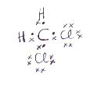
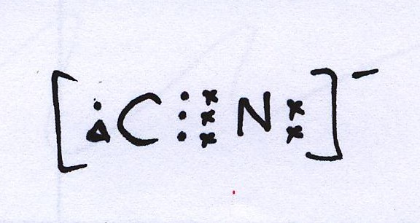

c) PCl₅ d) NO₃⁻
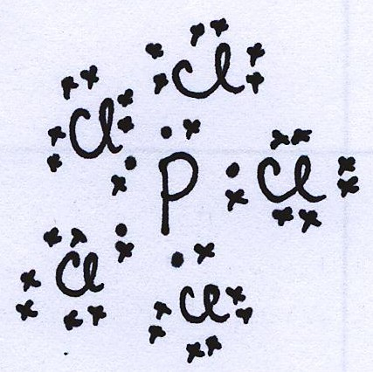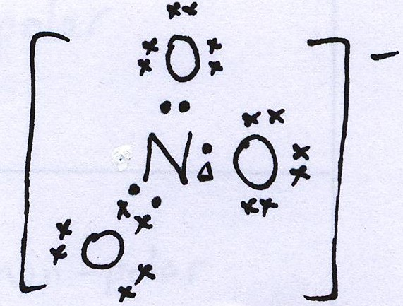
(4 marks)

2. (i)
- SbH₃ is ionic and will have the highest boiling point due to strong electrostatic forces between the cations and anions (1 mark)
- Both PH₃ and AsH₃ are covalent molecular substances made of polar molecules. (1 mark)
- AsH₃ has a larger molecular mass than PH₃ and therefore has more electrons and will have larger temporary dipoles and a higher boiling point. (1 mark)

(ii)
With aid of diagram (1 mark)
Polar due to the lone pair of electrons on the central group V atom making the distribution of electrons unsymmetrical (1 mark)

(iii)
- Hydrogen bonding (1 mark)
- Due to very electronegative N being bonded to a H atom leads to the H atom developing an appreciable positive charge which is attracted to lone pairs of electrons on neighbouring molecules.
H H
H N : --------- ^{S+}H – N :

H H (1 mark)
H-bonding
3.

 | Shape | Polarity
PF₃ | Pyramidal | Polar
HC₂H | linear | Non-polar
H₂O | v-shaped or bent | polar
(6 marks)

4.
a) 1s²2s²2p⁶3s²3p⁶4s²3d⁸ (28 electrons)
b) 1s²2s²2p⁶3s²3p⁶ (18 electrons)
c) 1s²2s²2p⁶3s²3p⁶4s²3d⁹ (29 electrons)
d) 1s²2s²2p⁶3s²3p⁶ (18 electrons)
(4 marks)

Part Three: Calculations

1.

2Fe₂O₃.Cr₂O₃ + 4Na₂CO₃ + 3O₂(g) → 2Fe₂O₃ + 4Na₂CrO₄(s) + 4CO₂(g)

1 000 000g

a) ^{n}FeO₃.Cr₂O₃ = 1 000 000 = 1 000 000 = 3208.2
(2 x 55.85 + 3 x 16 + 2 x 52 + 3 x 16) 311.7
(1 mark)
moles Na₂CO₃ = 4 x moles Fe₂O₃.Cr₂O₃ = 6416.4 mol
2 (1 mark)

mass Na₂CO₃ = 6416.4 x (2 x 22.99 + 12.01 + 3 x 16)
= 6416.4 x 105.99
= 680 176.997g (1 mark)

b) moles O₂ = 3 x moles Fe₂O₃.Cr₂O₃
2
= 3 x 6416.4 = 9624.6 (1 mark)
2
PV = nRT
(98) V = (9624.6)(8.315)(30 + 273)
=> V = 819.7 L
= 820 L (to 3 sig fig) (1 mark)

